Faculty Profile
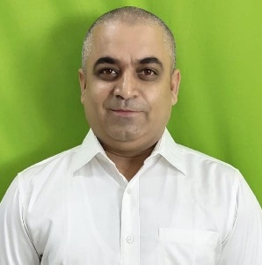
- Basic Information
- Name: Mr. Atul Chakrawarti
- Designation: Senior Associate Professor
- Department/School: Mechanical Engineering
- Institution Name: Shri Shankaracharya Institute of Professional Management & Technology, Raipur
- Email ID: a.chakrawarti@ssipmt.com
- Contact Number: 9617020000
- Photograph: (Passport-size, professional)

- Educational Qualifications
Degree | Specialization | Institution | Year of Completion
UG | Mechanical | BIT Durg | 1999
PG | Production | BIT Durg | 2007
Ph.D. | - | - | -
Others | C-DAC | Ahmedabad | 2000

- Teaching & Research Experience
- Total Teaching Experience: 25 Years
- Industry Experience: (if any)
- Research Experience:

- Courses Taught
- List of key UG/PG courses taught: Engineering Mechanics, Robotics, Manufacturing Process,

- Research Interests / Specialization
- Key thematic areas or domains of expertise: Mechatronics

- Publications (Last 5 Years)
- Journals (APA/IEEE format) - Nil
- Conference Proceedings - Nil
- Book Chapters / Books Authored – Nil

- Research Guidance
Level | Awarded | Ongoing
Ph.D.
PG

- Awards & Recognitions
- National: AICTE Idea Lab Techfest: 2nd prize in India

- Administrative Roles
- Member Board of Governors
- Professor In charge Admission

- Professional Memberships
- ISTE Life Member

- Web Presence
- Personal academic webpage / Google Scholar/ ResearchGate / ORCID: Nil

- Patent

- 06 Indian Utility Patent Grants
- 08 Indian Design patents
- 01 Copyright: Chakrawarti’s Theorem

- Startups

- Proprietary
- LLP
- Pvt. Ltd.

